|  |  |
| --- | --- |
| **Practicum Case** |  |
| CPEN6247 | CPEN6247001  Computer Networks |
| **Computer Engineering** | **O221-CPEN6247-PH01-01** |
| ***Valid on*** *Odd Semester Year 2021/2022* | **Revision 00** |

## Learning Outcomes

* LO1 – basic concepts of network

## Topic

* Session 1 – Computer Network Introduction

## Sub Topics

* Network Topology
* Network Devices
* OSI 7 Layer
* Crimping Cables
* Introduction to Packet Tracer

## Soal

*Case*

1. **Introduction**

The computer network is a system that consists of computers and other devices. These devices are connected using media to communicate with each other.

The **purpose** of a computer network are:

* Communication, such as email and telephone.
* Information access, such as web browsing.
* Resource sharing, such as printer sharing.

By its size, a computer network can be **categorized** into four types:

* LAN (Local Area Network)
* PAN (Personal Area Network)
* MAN (Metropolitan Area Network)
* WAN (Wide Area Network)

1. **Topology**

Network topology is the arrangement or pattern that is used to connect each node inside a network. Based on the arrangement or pattern, a network topology can be grouped like below.

* **Bus Topology**

Bus topology is a topology where all nodes are connected using a single cable. This cable is called the backbone. This will result in when this backbone failed, the entire topology will also fail.

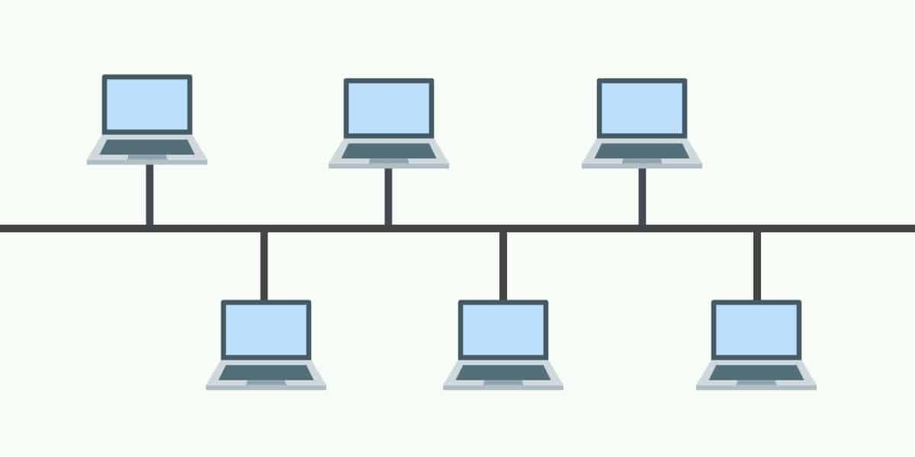

* **Star Topology**

In star topology, all the nodes are connected to a single point using a cable. This single point is usually a hub or a switch.

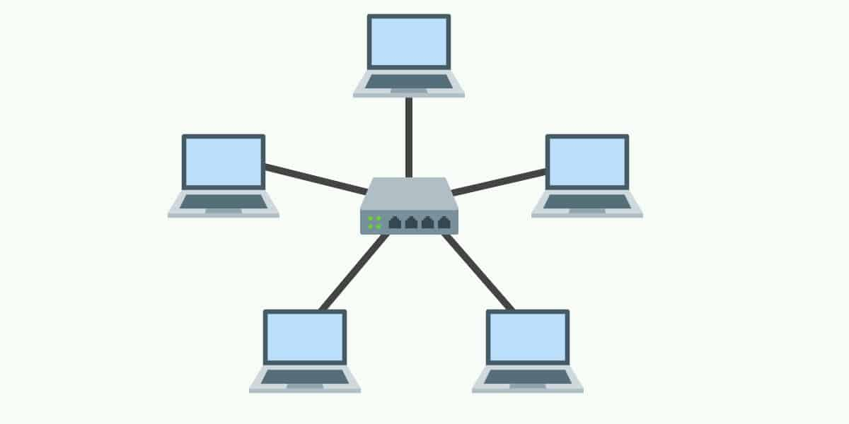

* **Ring Topology**

In this topology, the node will connect to another node using a cable until it forms a ring shape. Ring topology will use a large amount of repeater because when someone wanted to send data to the last node, then that data must pass through the rest of the node. Therefore, a repeater is needed to prevent packet loss. Furthermore, when one of those links is failing, then the rest of the topology will also fail because of the way each node is connected.

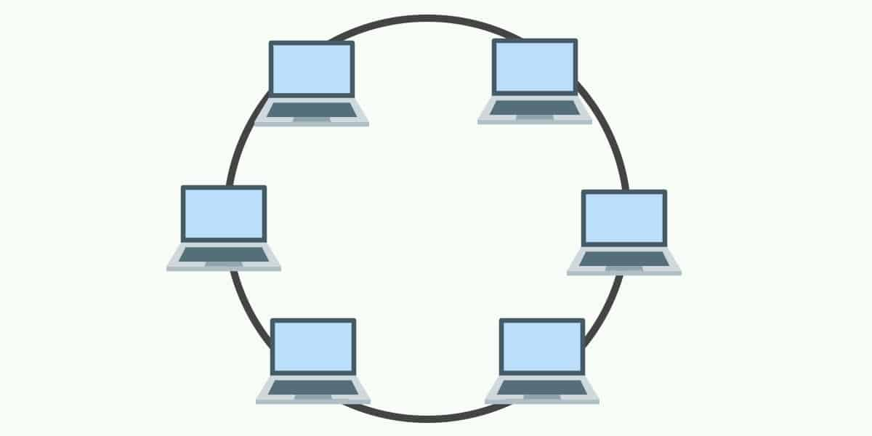

* **Mesh Topology**

Mesh topology is different when we compare it to other topologies. In this topology, all the nodes are connected. Because all nodes are connected, this topology will still allow communication even if one of the links is failing.

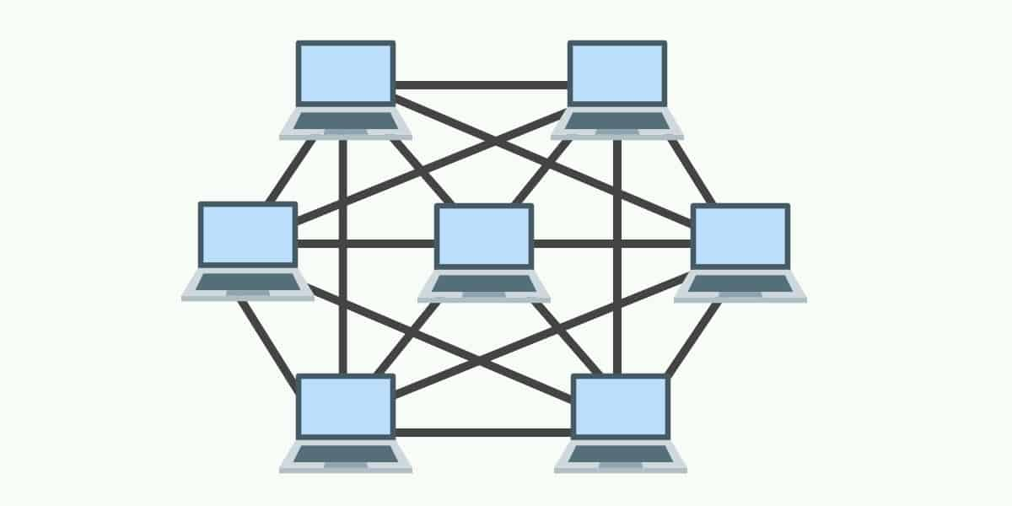

* **Tree Topology**

Tree topology is a topology where all of the computers are connected to form like branches of a tree. This topology is frequently used to organize a group of computers in a corporate network. A tree topology combines the characteristic of bus topology and star topology where the devices will be connected using a star topology and those stars topology will be connected using a bus topology.

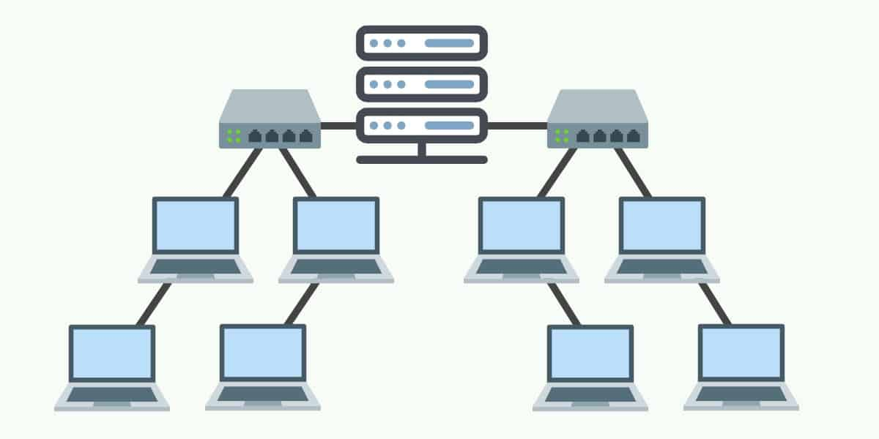

1. **Media**

One of the media in a computer network is cable. There is a lot of different type of cable that is being used each with their specification and capability. There are three commonly used type of cable:

* **Coaxial**

Coaxial is one of the commonly used cables by a cable operator, telephone and also internet. A coaxial cable has a shield that allows the cable to transmit data quickly without losing it. Inside, there is a copper conductor that is being covered with insulation made from aluminum.

* **Twisted Pair**

Twisted pair is a cable where the two conductors inside are combined to reduce or to remove electromagnetic interference. The twisted pair will be divided into 2 categories, Unshielded Twisted Pair and Shielded Twisted Pair. The difference between the two is an extra foil shield inside the cable which the Shielded Twisted Pair has and the Unshielded Twisted Pair doesn't.

* **Fiber Optic**

Fiber optic is different from the first two cables because fiber optic uses light to transfer data. This cable will convert the electric signal to light and then send it to the other end. Fiber optic is made of strands of glass and plastic. Because fiber optic is using light to transfer data, it will result in a faster speed and a further reach.

1. **Device**

There are seven commonly used type of network device:

* **Hub**

Hub is a device that will allow multiple computers to communicate with each other. A hub is like a switch, the difference is when a packet comes from a port, that data will be broadcasted to every port without considering the destination.

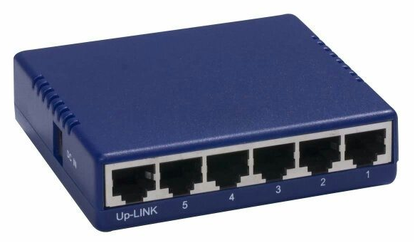

* **Switch**

The switch is a device that operates in the data link layer. A switch is similar to a Hub where it allows multiple computers to communicate with each other. It will take the incoming packet from a port and then sends them again to the destination. The difference with Hub is, a switch will read the header of the packet and send the packet to the corresponding destination.

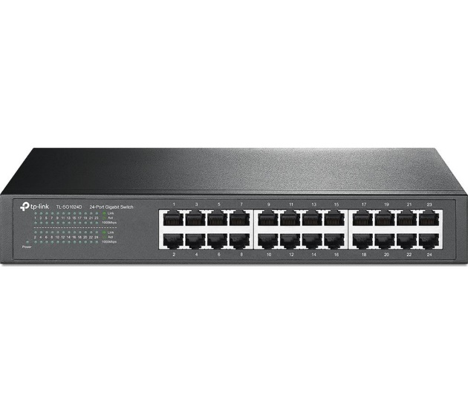

* **Router**

The router is a device that will route a packet based on their IP addresses. The router is a network layer device. A router can help send a packet to their destination by making a path through the computer network. To do this, they store information about the networks that they are connected to.

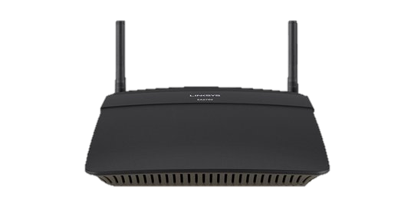

* **Bridge**

The bridge is a device that can connect a network to another network. One of the advantages of using a bridge is that a bridge can connect different types of a computer networks such as Ethernet with Fast Ethernet. A bridge can look at the MAC address of each connected device and forward incoming data or block it from crossing.

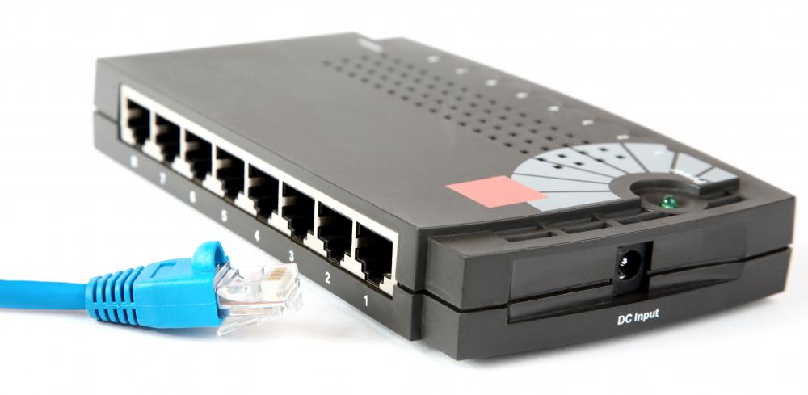

* **Modem**

The modem is a device that is used to send or receive data over telephone or cable lines. The main function of a modem is to convert a digital signal into analog or vice versa.

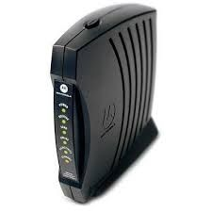

* **Repeater**

The repeater is a device that is used to amplify the signal that it receives. A repeater will receive data and then send it back with a higher power of signal so the signal can cover a lot more distance.

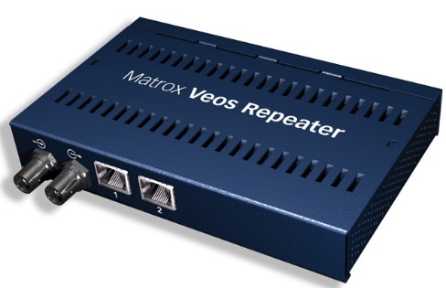

* **Access Point**

The access point is a device that can create a wireless local area network. An access point can connect to a router or a switch and project a wireless signal to an area. The difference between a router and an access point is that the access point only projecting a wireless signal meanwhile router can be used to connect multiple devices inside a local network.

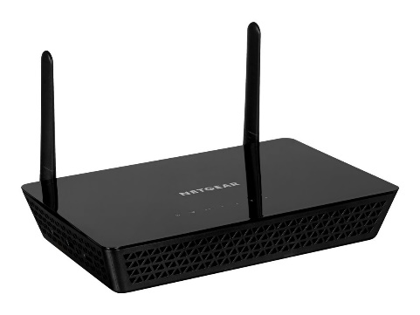

1. **OSI Layer**

OSI Layer is made by International Organization for Standardization (ISO) to become a protocol for all network communication. This is needed because as we know there is a lot of different network devices. If there is no standardization for the communication between those devices, communication between those devices will require much more effort. There is 7 layer in OSI layer, each with their different responsibility. Those layers are:

* 1. **Application**, will be the layer that is connected to the user
  2. **Presentation**, will be the layer that is responsible to prepare the data so that it can be used by the program
  3. **Session**, will be the layer that is responsible to open the network for the duration that is needed so that the data transfer can be done
  4. **Transport**, will be the layer that is responsible to send messages between two devices, receive data, and also forwarding it to the next layer
  5. **Network**, will be the layer that is responsible to make the route from one network to another network. If the communication occurs in the same network that this layer is not needed
  6. **Data Link**, will be the layer that is responsible to make the route inside the same network
  7. **Physical**, will be the layer that is responsible to transmit data in form of a bitstream.

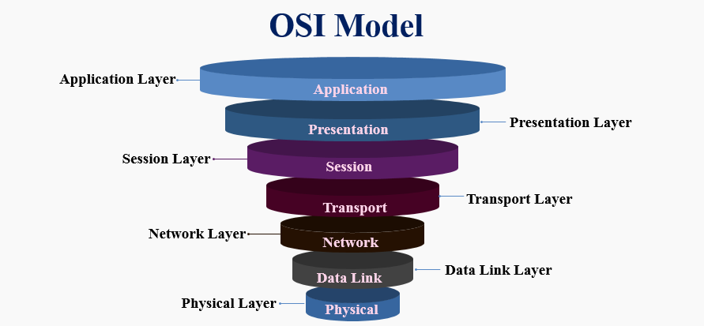

1. **Crimping Cables**

UTP cable is one of the most used cables. Inside there is a spiral arranged cable and unshielded. This makes the cable less resistant to electromagnetic interference. UTP Cable has 7 different category that ranges from category 1 to category 7. Category 5 is one of the most common categories. Category 5 also has a different type of cable as shown below:

* **Straight Through**

Used to connect different type of devices, such as a computer with a switch.

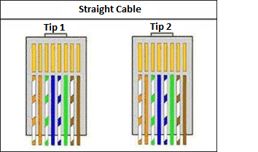

**Tip 1 Standard:**

* Pin 1 White – Orange
* Pin 2 Orange
* Pin 3 White – Green
* Pin 4 Blue
* Pin 5 Blue – White
* Pin 6 Green
* Pin 7 White – Brown
* Pin 8 Brown

**Tip 2 Standard:**

* Pin 1 White – Orange
* Pin 2 Orange
* Pin 3 White – Green
* Pin 4 Blue
* Pin 5 Blue – White
* Pin 6 Green
* Pin 7 White – Brown
* Pin 8 Brown
* **Cross Over**

Used to connect devices with the same type, such as computer to computer.

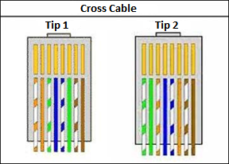

**Tip 1 Standard:**

* Pin 1 White – Orange
* Pin 2 Orange
* Pin 3 White – Green
* Pin 4 Blue
* Pin 5 Blue – White
* Pin 6 Green
* Pin 7 White – Brown
* Pin 8 Brown

**Tip 2 Cross:**

* Pin 1 White – Green
* Pin 2 Green
* Pin 3 White – Orange
* Pin 4 Blue
* Pin 5 Blue – White
* Pin 6 Orange
* Pin 7 White – Brown
* Pin 8 Brown

To crimp a cable, you can follow the following steps,

* 1. Prepare all the tools needed
     1. Crimping tool



* + 1. UTP cable



* + 1. RJ-45

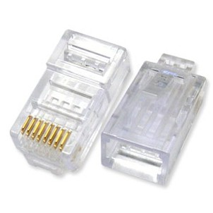

* 1. Peel the tip of the UTP cable using a crimping tool.
  2. Arrange the color based on the cable type below.
  3. Cut the cable neatly using the crimping tool.
  4. Insert the cable to the RJ-45 connector so that the tip of the cable is visible in front side of the RJ-45.

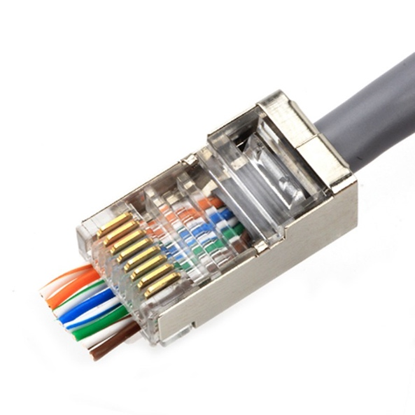

* 1. Lock the RJ-45 cable by inserting it into the crimping tool to press it so that it is completely attached to the RJ-45.
  2. Test the cable by connecting it to a computer.

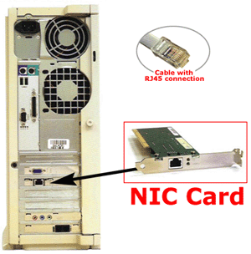

* 1. To test the cable, try connecting 2 computers with the LAN cable that has been made and then use "ping [computer's IP address]" in the command prompt. To check the IP address you can use ipconfig in the command prompt

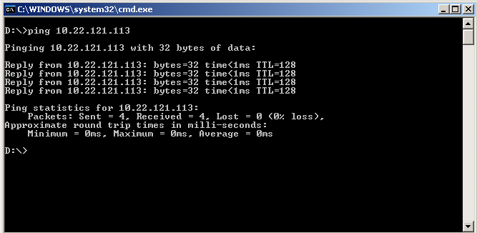

1. **Packet Tracer**

Cisco packet tracer is a network simulator that is made by Cisco System to allow their user to make a network topology or just simply learn about networking. Cisco packet tracer is not only helping a student to learn the basics of networking but also helping network engineer to simulate their network devices first. Below is the interface of Cisco Packet Tracer:

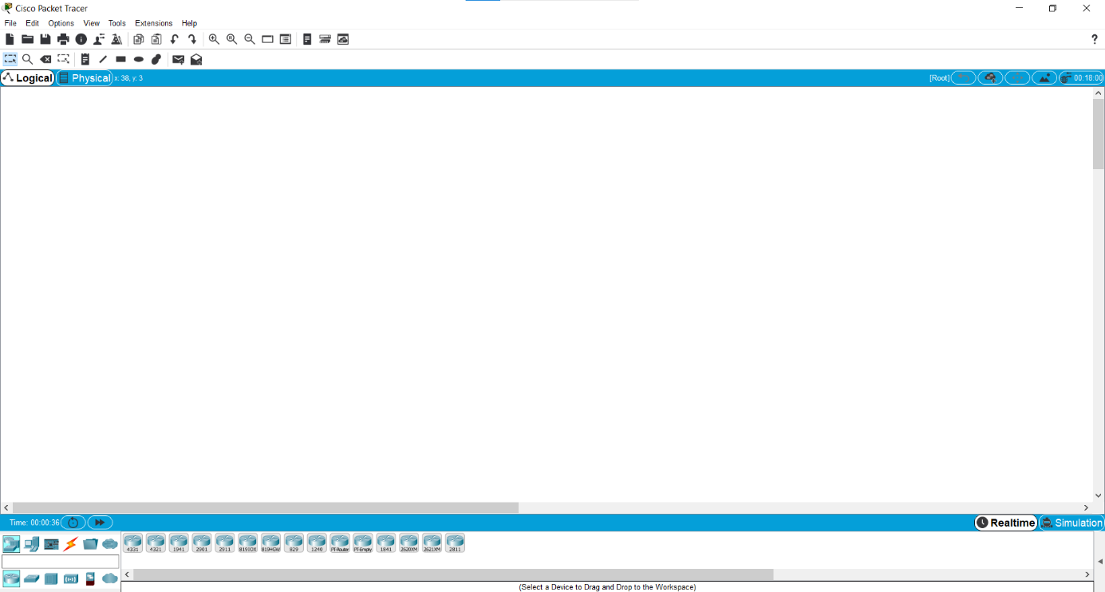

For the network devices that are available in Cisco Packet Tracer, there are

|  |  |  |
| --- | --- | --- |
| Symbol | Name | Description |
|  | Routers | To forward a packet from one network to another network |
|  | Switches | To forward a packet to the destination from the same network |
|  | Hubs | To forward a packet to the destination from the same network |
|  | Wireless Devices | To project a wireless signal connection |
|  | Cable Connection | To connect devices |
|  | WAN Emulation | To emulate a Wide Area Network model |
|  | End Devices | The devices that will be using the network |

1. **Case**

You are asked to give each device an IP address based on the picture below. Open the given 01.pka file and follow the instruction given.

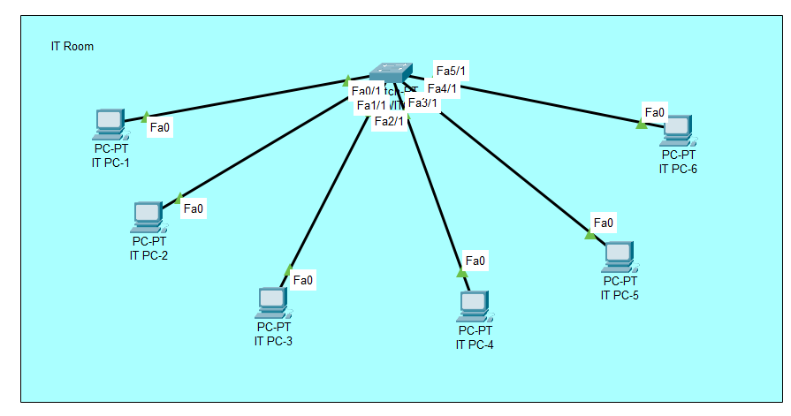

**Reference:**

<https://cdn.comparitech.com/wp-content/uploads/2018/11/Bus-Topology.jpg>

<https://cdn.comparitech.com/wp-content/uploads/2018/11/star-Topology.jpg>

<https://cdn.comparitech.com/wp-content/uploads/2018/11/Ring-Topology.jpg>

<https://cdn.comparitech.com/wp-content/uploads/2018/11/Mesh-Topology.jpg>

<https://cdn.comparitech.com/wp-content/uploads/2018/11/Tree-Topology.jpg>

<https://thecybersecuritymancom.files.wordpress.com/2018/01/hub4.png?w=583>

<https://brain-images-ssl.cdn.dixons.com/2/7/21429272/u_21429272.jpg>

<https://cdns.klimg.com/merdeka.com/i/w/news/2020/04/30/1172623/540x270/3-fungsi-router-pahami-cara-kerja-dan-perbedaannya-dengan-modem.jpg>

<https://images.easytechjunkie.com/network-hub-with-cable.jpg>

<https://i.pinimg.com/originals/bd/0a/0e/bd0a0eb6f7830481c03248962767f87d.jpg>

<https://3.imimg.com/data3/HO/GO/MY-4145714/networking-repeater-500x500.jpg>

<https://www.comms-express.com/blog/wp-content/uploads/2018/08/xNetgear-wireless-access-point.jpg.pagespeed.ic.SeEp_dzr4m.jpg>

<https://yuliantisafitri.files.wordpress.com/2009/10/osigroupedlayers.jpeg?w=460>

<https://images.tokopedia.net/img/cache/500-square/product-1/2020/6/23/batch-upload/batch-upload_23199775-68b2-4d07-9cee-14c6688760b4.jpg>

<https://cf.shopee.co.id/file/80ca2800c31762a7b1305224b5d92ad6>